Here is the comprehensive documentation of the details and formulas based on the research article¹.
1. Solar PV Panel Technical Specifications
The calculations rely on the specific characteristics of the 10W panels used in the study².
Parameter | Symbol | Value (at STC)
Maximum Power | $P_m$ | 10 W
Maximum Power Voltage | $V_m$ | 20 V
Maximum Power Current | $I_{im}$ | 0.50 A
Short Circuit Current | $I_{sc}$ | 0.60 A
Open Circuit Voltage | $V_{oc}$ | 24.8 V
Temp. Coefficient ($P_m$) | $\beta_p$ | $-0.3\%/^{\circ}C$ to $-0.5\%/^{\circ}C$
Temp. Coefficient ($I_{im}$) | $\alpha_{Im}$ | $+0.1\%/^{\circ}C$
Temp. Coefficient ($V_m$) | $\beta_{Vm}$ | $-0.38\%/^{\circ}C$

2. Core Mathematical Formulas
A. Cell Temperature ($T_{cell}$)
The real-world temperature of the solar cell is calculated based on ambient conditions and irradiation4.
$$T_{cell} = T_{\infty} + 0.078 H_{g}$$
- $T_{\infty}$: Ambient air temperature ($^{\circ}C$)⁵.
- $H_g$: Global inclined solar irradiance ($W/m^2$)⁶.
B. Real Power Output ($P_{pv}$)
This formula estimates power under real operation and climatic conditions7.
$$P_{pv} = P_{stc} \times DF_{pv} \times (H_g / H_{stc}) \times [1 + \beta_p(T_{cell} - T_{stc})]$$
- $P_{stc}$: Nominal PV power at STC (10 W)⁸.
- $H_{stc}$: Standard solar radiation (1000 $W/m^2$)⁹.
- $T_{stc}$: Standard test temperature (25 °C)¹⁰.
- $DF_{pv}$: PV derating factor¹¹.
C. Output Current ($I$) - Single Diode Model
The standard electrical behavior of the PV cell is represented by this equation12.
$$I = I_{ph} - I_0 \left( e^{\frac{q(V + I R_s)}{n k T}} - 1 \right) - \left( \frac{V + I R_s}{R_{sh}} \right)$$
- $I_{ph}$: Photocurrent¹³.
- $I_0$: Diode saturation current¹⁴.
- $R_s$ / $R_{sh}$: Series and Shunt resistances¹⁵.
- $n$: Ideality factor¹⁶.
D. Fill Factor ($FF$)
This represents the ratio of maximum power to the theoretical power17171717.
$$FF = \frac{P_m}{V_{oc} \times I_{sc}}$$

3. Array Configuration Scaling (Se-P Topology)
The experiment utilized a 12-panel Series-Parallel (Se-P) array in a $3 \times 4$ arrangement¹⁸¹⁸¹⁸. To calculate the final array values, you must scale the single-panel results:
- Array $V_{oc}$: $V_{oc,panel} \times 3$ (Number of panels in series)¹⁹.
- Array $I_{sc}$: $I_{sc,panel} \times 4$ (Number of strings in parallel)²⁰.
- Array $V_m$: $V_{m,panel} \times 3$²¹.
- Array $I_m$: $I_{m,panel} \times 4$²².
- Array $P_m$: $V_{m,array} \times I_{m,array}$²³.

4. Experimental Positioning Details
The study highlights that the output power depends heavily on the variance (mounting height) and positioning²⁴²⁴²⁴²⁴.
- Flat Position (FP): Panels placed horizontally at 180°²⁵.
- Highest Performance Setup: Achieving 156 W with a flat-position array at a 93 cm variance using Se-P interconnection²⁶.
- Footprint Optimization: While FP yields more power, V-shape (VP) and Inverted V-shape (IVP) are strategic for reducing the land footprint in urban environments²⁷²⁷²⁷²⁷²⁷²⁷²⁷²⁷²⁷.

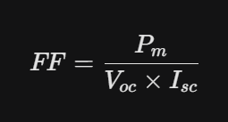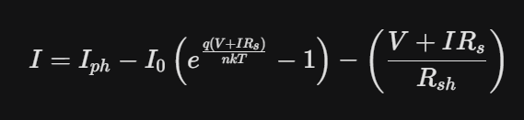
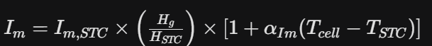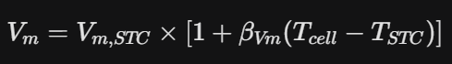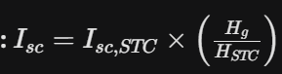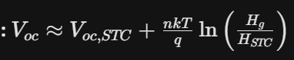
code
import csv
from datetime import datetime, timedelta
import math
import random

def generate_summer_pv_csv(
start_date="2025-04-01",
months=3,
output_file="pv_summer_apr_may_jun.csv"
):
# ===============================
# SYSTEM CONSTANTS (from paper)
# ===============================
FF = 0.67
Voc_stc = 24.8
Isc_stc = 0.60
T_stc = 25

n_series = 4
n_parallel = 3

beta_voc = -0.0038 # −0.38 % / °C
alpha_isc = 0.001 # +0.1 % / °C

current_loss_factor = 0.82
voltage_factor = 0.84
vm_ratio = 0.80

# Time slots: 08:30 – 18:30 (summer longer sun)
time_slots = [
(datetime.strptime("08:30", "%H:%M") + timedelta(minutes=30*i)).strftime("%H:%M")
for i in range(21)
]

start_dt = datetime.strptime(start_date, "%Y-%m-%d")
end_dt = start_dt + timedelta(days=months * 30)

with open(output_file, mode="w", newline="") as file:
writer = csv.writer(file)
writer.writerow([
"Date", "Time", "Irradiation_Wm2", "AmbientTemp_C", "CellTemp_C",
"Voc_V", "Isc_A", "Vm_V", "Im_A", "Pm_W", "FF"
])

current_date = start_dt

while current_date < end_dt:
# Summer ambient temperature
T_ambient = random.uniform(32, 42)

# Higher summer peak irradiation
daily_peak = random.randint(1050, 1150)

for idx, time_str in enumerate(time_slots):
# Summer irradiation curve (wider bell)
angle = (idx / (len(time_slots) - 1)) * math.pi
irradiation = max(
250,
daily_peak * math.sin(angle) + random.uniform(-40, 40)
)

# Cell temperature (summer realistic)
T_cell = T_ambient + (0.025 * irradiation / 10)
delta_T = T_cell - T_stc

# -------------------------------
# ELECTRICAL CALCULATIONS
# -------------------------------
Isc_panel = (
Isc_stc *
(irradiation / 1000) *
(1 + alpha_isc * delta_T) *
current_loss_factor
)
Isc_array = Isc_panel * n_parallel

Voc_panel = (
Voc_stc *
voltage_factor *
(1 + beta_voc * delta_T)
)
Voc_array = Voc_panel * n_series

Vm_array = vm_ratio * Voc_array
Pm_array = FF * Voc_array * Isc_array
Im_array = Pm_array / Vm_array if Vm_array > 0 else 0

writer.writerow([
current_date.strftime("%Y-%m-%d"),
time_str,
int(irradiation),
round(T_ambient, 1),
round(T_cell, 1),
round(Voc_array, 2),
round(Isc_array, 2),
round(Vm_array, 2),
round(Im_array, 2),
round(Pm_array, 0),
FF
])

current_date += timedelta(days=1)

print(f"✅ Summer CSV generated: {output_file}")

# RUN
generate_summer_pv_csv()

